Shree Swanra Integrated Community Development Centre (SSICDC), Gorkha
Organization Profile

Brief introduction of organization

Background:

Shree Swanra Integrated Community Development Center (SSICDC) Gorkha is a non-political, non-governmental and non-profit making organization established by young and energetic youths in 1987 AD. The Organization has been working continuously since its establishment with theMarginalized, poorest and downtrodden people who are typically the social outcaste, women, children and the disadvantaged group, in general, of different castes and races.
The overall programs coverage of the organization is WASH, Education, Social Mobilization, GESI, Food Security and Livelihood, Shelter, Infrastructure, Health and Nutrition, Tourism Development, Child Protection, Disaster Risk Reduction (DRR), Emergency rescue, response and recovery, Climate Change Adaptation and Bio- Diversity conservation.
It is one of the local levels leading NGO that has adopted participatory approaches in working with the marginalized families and communities in delivering developmental program in Nepal. It has the privilege of being a community based, locally recognized for its goodwill and the image within the community.
SSICDC Gorkha played the leading role in the Rescue, Relief, Recovery and Reconstruction of the Gorkha Earthquake as well as play leading role to combating against the CORONA Virus Pandemic in Gorkha.
Name of the Organization:
Shree Swanra Integrated Community Development Centre (SSICDC), Gorkha
- Date of establishment: 17th September 1987
- Registration:
District Administrative Office (D.A.O.), Gorkha, Regd. No.: 132, Date: 2nd March 1994
Latest Renewal Date: 2080/07/17 B.S.
Social Welfare Council (SWC) Regd No.: 1863 Date: 26th September 1994
Latest Renewal Date: 2080/04/24 B.S (to 2082/03/30 B.S.)
- Working district: Gorkha, Dolpa and Lamjung.
- Contract Person: Sita Ram Shrestha (Educative Director), Contract No: 9841683867
Email: -shresthasitaram5@yahoo.com
- Membership: General Member: 89
Executive Member: 7
- Address: Gorkha Municipality-6, Chhahare, Gorkha (Head Office)
Phone: 064-421377
Email – gorkhassicdc@gmail.com
Web: -www.ssicdc.org.np
- PAN/VAT No.: 302174593

- Vision, Mission, Goals and Objectives of organization:

  - Vision of Organization:

SSICDC’s vision of the future is a society where people’s rights are fully respected with opportunities to lead a productive, happy and dignified human life irrespective of their religion, sex & caste and material condition.

  - Mission of Organization:

SSICDC works to encourage people’s participation in development process through capacity building of the communities. It supports local initiative to create a better future of the rural backward communities. This will be attempted through strengthening the civil society, especially the user groups complementing the local government efforts.

  - Goals of Organization:

The overall goal of SSICDC is to contribute meaningfully to improve the quality of life of rural backward communities of Nepal.

  - Objectives of the Organization:

The main objectives of the organization are to:

- Conduct Child Rights and Development Programs.
- Conduct women empowerment programs.
- Sustainable agriculture development.
- Lunch programs in human rights and social inclusion.
- Deliver sustainable health and hygiene benefits to the rural people through the provision of safe Drinking water interlinked with low-cost sanitation and health education.
- Improve rural Infrastructure facilities like foot trails, trail bridges, micro irrigation, micro hydropower, community buildings and rural roads etc.
- Promote saving and credit & Co-operative.
- Develop and promote appropriate technologies in rural area.
- Develop, disseminate and promote renewable energy technologies in rural area.
- Conserve environment and natural resources & encourage its sustainable use.
Create and prepare good learning environment for quality inclusive education.
- Create the employment opportunities through various income generating and vocational training.
- Organize the awareness program and other different social, economic and educational programs for the upliftment of marginalized group.
- Conduct the programs for the improvement of livelihood focused on tourism, livestock and
medicinal herbs.

- Executive Board Profile:
Description |  |  | Dalit |  | Janjati |  | Other |  | Total
 |  |  | M | F | M | F | M | F | M | F
General Members |  |  |  |  |  |  |  |  | 57 | 32
Executive Board
S.N | Name | Position
1. | Krishna Kumari Gurung | Chair person |  |  |  | 1
2. | Shankar Nepali | Vic-Chair Person | 1
3. | Devi Maya Thapamagar | Treasurer |  |  |  | 1
4. | Hariman Gurung | Secretary |  |  | 1
5. | Yam Narayan Shrestha | Member |  |  | 1
6. | Gyan Maya Gurung | Member |  |  |  | 1
7. | Tulasi Babu Shrestha | Member |  |  | 1

4. Experiences of Organization:
The following depicts the experiences of organization shortly:
4.1:
Name of the Program: | Integrated Community Development Program | Thematic Area of the Program: | Social Mobilization, Education, women empowerment, infrastructure development, livelihood, health.
Project Duration: | From: 1988 A.D.  To: 1997 A.D. | Budget: | NRs. 37,00,000/-
Project Area: | Erstwhile 24 VDC of Gorkha | Project Partner: | Save the Children US
Key Activities: | 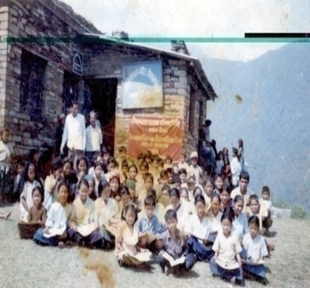  Child Education, Adult Education, Scholarship for Students, Women Empowerment, Community Group Mobilization and Micro Credit Support, Income Generation Program, Agro Forestry, Saving and Credit, Drinking Water Supply and Sanitation, Goat Raising, Poultry Farming, MCH Clinic, Health Camp, Sponsor Child Health Camp, family planning, School Building Construction, Irrigation, Wooden Bridge Building, Vegetable Farming, Pig Raising and Child survival project, CHV and VHP Training, First Aid Training and kit Box distribution to school Teachers, Safe Motherhood Program, Nutrition and Immunization Program for Under 5 children, School Health Education program, Sponsor children Health check camp etc.  Child Education at NGO Office, Swanra VDC Gorkha
4.2.
Name of the Program: | HIV/AIDS Control Program | Thematic Area of the Program: | Health
Project Duration: | From: 2001 A.D.  To: 2003 A.D. | Budget: | NRs. 20,44,000/-
Project Area: | Erstwhile 6 VDCs of Gorkha | Project Partner: | SNV/ DGIS
Key Activities: | 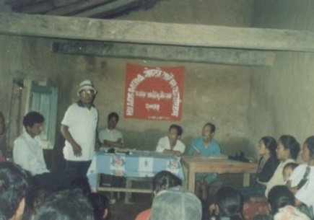  Peer Educator Counseling Training, Video Show, Puppet Show, Street Drama show, World AIDS Day and Condom Day Celebration, Game, Essay, Speech Competition, IEC Material distribution, Workshop, Rally, Condom distribution, SAFALTAM Income Generation Program, and Hoarding Board display etc.  Awareness raising workshop on HIV/AIDS
4.3.
Name of the Program: | Non-formal education program | Thematic Area of the Program: | Education
Project Duration: | From: December, 1997 A.D.  To: May, 1998 A.D. | Budget: | NRs.: 264400
Project Area: | Erstwhile Swanra VDC of Gorkha district. | Project Partner: | District Education Office (DEO), Gorkha
Key Activities: | Conducted the non-formal education activities (child education-Bihani kachha, adult education- praud kakesha, pindhi kakesha etc.)
4.4.
Name of the Program: | Dhaka Knitting Training | Thematic Area of the Program: | Livelihood
Project Duration: | From: October, 1994 A.D.  To: March, 1995 A.D. | Budget: | NRs.:131000
Project Area: | Erstwhile Swanra VDC of Gorkha district. | Project Partner: | Skill development center, pokhara
Key Activities: | Skilled base training to 25 persons. (dhaka knitting training)
4.5.
Name of the Program: | Rural Water Supply and Sanitation Project Gorkha. (RWSSFDB) | Thematic Area of the Program: | WASH, social mobilization
Project Duration: | From: March 1998  To: December 2011 | Budget: | NRs. 61,93,09,447/-
Project Area: | One Municipality and erstwhile 21 VDCs of Gorkha district. | Project Partner: | Fund Board/ World Bank
Key Activities: | 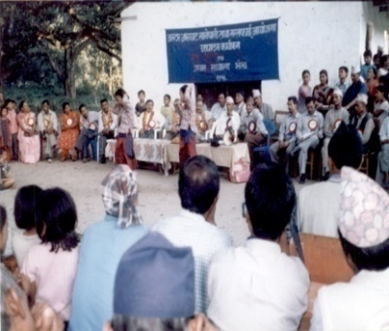  Social Mobilization, Feasibility study, survey, design, estimation of water supply schemes, formation of water supply and sanitation user committee and mobilization, Construction completed more than 24 water supply schemes, capacity development of WUSCs, ODF campaign, water safety plan preparation and implementation, operation and maintenance plan prepare and follow up, public hearing and social audit.  Opening of Aarughat Water Supply Scheme at Aarughat
4.6.
Name of the Program: | Community Based Water Supply and Sanitation Program (CBWSSP), Dolpa | Thematic Area of the Program: | WASH, social Mobilization.
Project Duration: | From: March 2008  To: October 2011 | Budget: | NRs. 1,70,21,333/-
Project Area: | Erstwhile Tripurakot and Shunh VDCs of Dolpa District | Project Partner: | DDC, Dolpa / ADB
Key Activities: | 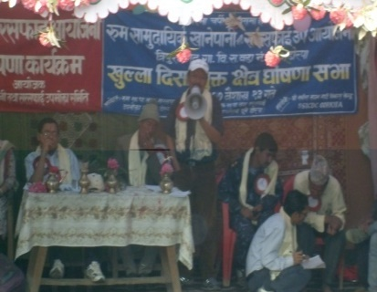  Social Mobilization, Feasibility study, survey, design, estimation of water supply schemes, formation of water supply and sanitation user committee and mobilization, Construction completed the 3 water supply schemes, capacity development of WUSCs, ODF campaign, water safety plan preparation and implementation, operation and maintenance plan prepare and follow up, public hearing and social audit.  ODF declare program on Water Supply Scheme area at Dolpa
4.7.
Name of the Program: | Decentralized Rural Infrastructure and Livelihood Program (DRILP) | Thematic Area of the Program: | Community mobilization, Infrastructure development, livelihood.
Project Duration: | From: April 2007 A.D.  To: August 2011 | Budget: | NRs. 23,34,71,491/-
Project Area: | Gorkha Municipality, Erstwhile VDCs-Phinam, Taple, Asrang, Baguwa, Masel, Tandrang, and Aaruchanute. | Project Partner: | District Development Committee (DDC), Gorkha / ADB
Key Activities: | 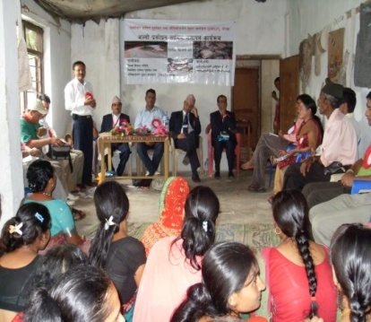  Social Mobilization- walkover, baseline, midline, end-line, socio-economic, cadastral and resettlement plan surveys, and compensation distribution, awareness raising training, life skilled training, community building, health post building constructions, foot trails constructions, school compounding wall, Dhungagade to Aarughat Road (38.22 KM) upgrading/graveling and bio-engineering on landslide area.  Closing on Allo Purification Training at G.M. – 10, Terhakilo
4.8.
Name of the Program: | Local Governance and Community Development Program (LGCDP) – I and II phase. | Thematic Area of Program: | Social Mobilization
Project Duration: | From: Feb 2011 to July 2012 and April 2015 To: March 2018 (project implemented in different 3 phases | Budget: | NRs. 37,71,036/
Project Area: | Gorkha Municipality & erstwhile 10 VDC of Gorkha | Project Partner: | DDC, Gorkha and Gorkha municipality & development partners
Key Activities: | 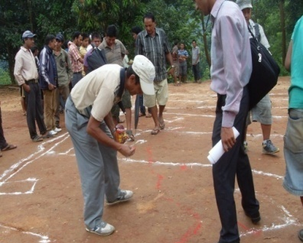  Social mobilization, Ward Citizen Forum (WCF) formation & mobilization, Community Awareness Center (CAC) formation and mobilization, REFLECT class conducted on CAC, facilitation of bottom up 11 step planning process local level, & support on IGA, exposer & learning visit, monitoring.  Social Mapping by Community at Ghyalchowk
4.9.
Name of the Program: | HIV/AIDS Comprehensive Program to migrant & their spouses. | Thematic Area of Program: | Health
Project Duration: | From: April 2012  To: March 2015 | Budget: | NRs. 1,14,42,676/-
Project Area: | Estwhile 24 VDCs and one municipality of Gorkha district. | Project Partner: | Save the Children/ Global fund
Key Activities: | 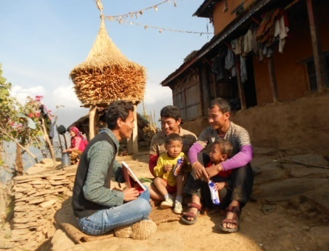  HIV/ AIDS Prevention program, Social mobilization, household visit and counseling and follow up, different level of orientation to different groups like migrant, spouse of migrants, women groups, teachers, FCHVs, transit, PLHIV etc. Day celebration (HIV/AIDS, condom, candle day), street drama show, radio jingle of HIV/Aids, IEC materials distribution, condom distribution, peer educator mobilization, provide Integrated Health Center services, video show, refer to STI/VCT/PMTCT/CD4/ARV, Support to PLHA through Community Based Home Care service, nutrition support to PLHA, Cass support to Child who is PLHA etc.  OW, Arjun Kumar Tamang is providing the BCC education on HIV/AIDS
4.10.
Name of the Program: | Hariyo Ban Program Phase I | Thematic Area of Program: | Climate Change Adaptation and Bio diversity conservation, sustainable landscape, Livelihood, Social mobilization, GESI.
Project Duration: | From: June 2013  To: July 2016 | Budget: | NRs. 4,32,08,930.3/-
Project Area: | Gorkha Municipality, Palungtar Municipality, Siranchok RM, Aajirkot RM, Bhimsen Thapa RM, Barpak-sulikot RM, Gondaki RM | Project Partner: | WWF Nepal/USAI D
Key Activities: | 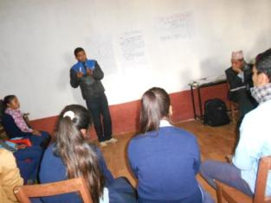  Social mobilization, Income generation activities (IGA), skilled based training and start up support, seed money revolving fund mobilization for IGA through local cooperatives. Herbal plant plantation & market linkage, Eco club formation & mobilization, awareness rising training, Community level Anti-pouching Unit formation & mobilization, sustainable landslide management, CAPA, LAPA preparation support and implementation, LIP preparation and implementation support, plantation, natural resource conservation, Home Stay Recovery Gajeghale Museum, Cultural Museum Building, Epicenter Trekking Trail, Tourist Information Center Construction, Rubinala Treaking Trail, Dharche Trekking Trail Reconstruction for tourism promotion, Home Stay Recovery Support, Bio-gash construction support, improve cooking stove installation support etc.  Eco Club orientation by F.S, Narayan Dhakal at BindhaBasini HSS, Nareswor
4.11.
Name of the Program: | Hariyo Ban Program- Phase I | Thematic Area of Program: | Climate Change Adaptation and Bio diversity conservation, Livelihood Recovery, Social mobilization, GESI, Good Governance.
Project Duration: | From: February 2014  To: October 2016 | Budget: | NRs. 6,01,11,376.1/-
Project Area: | Gorkha Municipality, Palungtar Municipality, Siranchok RM, Aajirkot RM, Bhimsen Thapa RM, Barpak-sulikot RM | Project Partner: | CARE Nepal/USAID
Key Activities: | Livelihood improvement plan preparation and Implementation support, income generation activities for community forest user group, green entrepreneurship for income generation such as nettle powder production, bio brigade production etc. development and market linkage etc. institutional capacity development of CFUG & cooperatives, eco-tourism promotion through home-stay, food trail construction for developing tracking root, CAPA and LAPA preparation and implementation support, support to registration and renew of CFUGs. Awareness raising training, Bio-gash construction support, improve cooking stove installation support etc.
4.12.
Name of the Program: | Youth Partnership Program | Thematic Area of Program: | Livelihood
Project Duration: | From: June 2011  To: May 2012 | Budget: | NRs. 2,41,100/-
Project Area: | Erstwhile Tanglichok and Ghyalchok VDCs Gorkha | Project Partner: | DDC, Gorkha
Key Activities: | 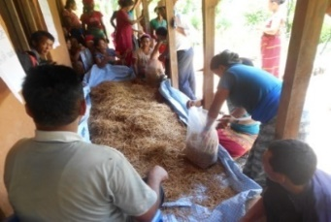  VDC level consultation meeting, community level consultation meeting, coordination with stakeholders/ line agencies, Mushroom cultivation training and spun (seed) & plastic support, supervision and follow up etc.  Participants of Mushroom cultivation training at Tanglichowk
4.13.
Name of the Program: | Improved Cooking Stove (ICS) Program | Thematic Area of Program: | DRR/ CCA & Social Mobilization
Project Duration: | From: April 2015  To: June 2016 | Budget: | NRs. 15,57,305/-
Project Area: | Gorkha District | Project Partner: | DDC, Gorkha/ AEPC
Key Activities: | 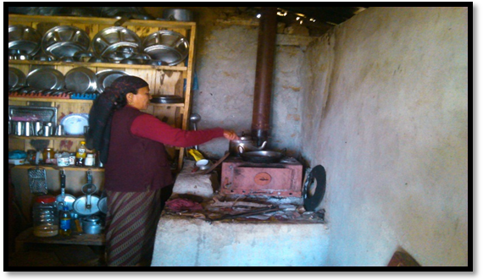  All the part of social mobilization, VDC level Orientation & consultation meeting, community level consultation meeting, coordination with stakeholders/ line agencies, VDC level Action Committee formation, selection of business groups, Mother group orientation for Behavior Change Communication, training of stove master/business groups, Indoor Air Pollution Free declare Community/VDC, supervision & monitoring, planning, reporting, recoding and documentation etc.  Using MICS by GhamraniGhale at Barpak
4.14.
Name of the Program | Shakeshar Nepal Aviyan Program | Thematic Area of Program | Education
Project Duration | From: March 2014  To: December, 2014 | Budget | NRs. 524128
Project Area | Erstwhile Aaruchanaute, Namjung and Saurpani VDCs of Gorkha | Project Partner | District Education Office, Gorkha
Key Activities | 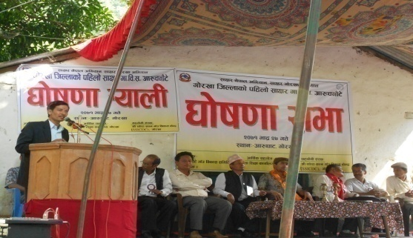  According to the plan and promise of GoN to declare Nepal as Literate Nepal by 2015.  All the part of social mobilization, VDC level Orientation & consultation meeting, community level consultation meeting, coordination with stakeholders/ line agencies, selection of sakesharata volunteer, mobilized sakesharata class, supervision & monitoring, planning, reporting, recoding and documentation, illiterate free declare VDC etc.  First Literate VDC Aaruchanaute declare Program of Gorkha district at Aarughat
4.15.
Name of the Program | Poverty Alleviation Program with JSDF project | Thematic Area of Program | Food Security and Livelihood Recovery, Entrepreneurship development, Social mobilization
Project Duration | From: June 2015  To: March 2019 | Budget | NRs. 8063025.68/-
Project Area | Aarughat RM, Ajirkot RM & Dharche RM, Gandaki RM, Palungtar Municipality and Gorkha Municipality of Gorkha district. | Project Partner | Poverty Alleviation Fund (PAF)
Key Activities | Social Mobilization, Value chain strengthening, Livelihood Recovery Support, Agriculture Infrastructure Construction support, Income generation Activity. Develop Agriculture Poket area. Entrepreneurship development and linkage to Nepal small industry, cottage construction for marketing, Skilled base/vocational trainings on handicraft skill training, social mobilization, social inclusion, wellbeing ranking, more than 80 community organization (CO) formation, registration and mobilization, developed business plan and implementation.
4.16.
Name of the Program: | Emergency Response and Recovery Program/ CARE | Thematic Area of Program: | Gorkha earthquake Emergency Response & recovery
Project Duration: | From: May 2015  To: December 2015 | Budget: | NRs. 1,16,25,127.9/
Project Area: | Palungtar Municipality, Siranchok RM, Barpak-sulikot RM, Dharche RM | Project Partner: | CARE Nepal
Key Activities: | Relief distribution (shelter tool kits, hygiene kits, family kits, CGI sheets, unconditional cash support)
4.17.
Name of the Program: | Emergency Response and Recovery Program | Thematic Area of the Program: | EQ Response & Recovery (Shelter, WASH, Health, Nutrition, Child Protection, FSL, DRR & Education)
Project Duration: | From: June 2015  To: December 2017 | Budget: | NRs. 36,58,52,238/-
Project Area: | Barpak Sulikot RM, Aarughat RM, Bhimsen Thapa RM, Siranchok RM  & Gorkha  Municipality. | Project Partner: | Save the Children
Key Activities: | Food security and livelihood activities: Seed storage bins and bags distribution, seeds distribution, unconditional cash support to 900 HHs, Vocational skills training, irrigational canal construction, training on of-seasonal & high value vegetable production, farmer field school conduct, goat rearing training & shed support, Amrisho distribution, fruits sapling distribution, Promotion for small entrepreneurs in the community level under market recovery project, Micro enterprise established 17 enterprise, Collection Center construction.  Shelter: Temporary shelter support (tarpaulin, CGI sheet or cash equivalent to CGI sheet), 450 HH supported NRs. 340000.00 for permanent shelter construction and Toilet maintenance and construction, Mason Training in 6 VDCs 200 person, Door to Door visit to Disseminate, key message for Build Back Better and Safer reconstruction, Media Mobilization for Safer Shelter Reconstruction 10 key message disseminate and technical support, Skilled Masson training 7 days and unskilled mason training 50 days, Build the Demonstration Building 6 nos, Door to Door technical support for build back better, safer and greener  Education: TLC (Temporary Learning Center) Construction 114 School TLC, Training conduction to teachers on Education on Emergency, ECD kits and educational materials distribution to schools, 8 School Building 64 classroom constructed, Support for disable friendly construction in school, training to school management committee, exposer & learning observation visit to teachers, school management committee.  Water Supply, Sanitation & Health (WASH): Water supply and sanitation scheme 21 Schemes, hygiene kit distribution, Hygiene promotion WASH related activities in the community level, School WASH Recovery 36 Schools.  Child Protection: Child protection activities, established endowment fund 8 Village Development Committees (VDCs) Rs. 725000 per VDC, Psychosocial counseling to earthquake affected people and Children., Street Drama and focus group discussion for community awareness, Child Friendly Space construction  Disaster Risk Reduction (DRR): Support to prepare Local level Disaster Risk Management Plan (LDRMP) for 6 VDCs, DRR plan prepare and implementation of 42 school of 6 VDCs  Health: Health Post Building and 11 ORC/PHC Building Construction, Support for disable friendly construction in health post, community building, Health, Nutrition and Sexual Reproductive and Maternal Health (SRMH) program.
4.18.
Name of the Program: | Earthquake Response and Recovery in Gorkha | Thematic Area of Program: | Emergency Response and Recovery (Shelter, WASH, FSL & DRR)
Project Duration: | From: June 2015  To: December 2017 | Budget: | NRs. 6,85,80,297.2/-
Project Area: | Siranchowk RM | Project Partner: | Lutheran World Relief (LWR)
Key Activities: | Livelihood activities: Cash for Work activities, improved vegetable seed distribution, maize, paddy seed support, technical training on off-seasonal & high value vegetable production, goat rearing training, goat & goat shelter support, WASH activities. Joint monitoring visits with government bodies  Shelter: CGI sheet and shelter tool kits support, 100 vulnerable household reconstruction support Rs. 3 lakha per HHs., skilled mason training, door to door assistant, socio technical support to safe house reconstruction.
4.19.
Name of the Program: | Livelihood Recovery Service Project (LRSP) | Thematic Area of Program: | Livelihood & DRR)
Project Duration: | From: February, 2017  To: Nov. 2019 | Budget: | NRs. 19325735.04
Project Area: | Siranchowk RM and Ajirkot RM | Project Partner: | Lutheran World Relief (LWR)
Key Activities: | Livelihood activities: Cash for Work activities, improved vegetable seed distribution, maize, paddy seed support, irrigation support, technical training on off-seasonal & high value vegetable production and startup support, goat, pig rearing training, goat & goat shelter support, market management on local level, market linkage of local agricultural products, support to establish & mobilize the weekly Haat bazzar at Bhachchek Bazzar, Joint monitoring visits with government bodies  DRR: awareness rising training on DRR to community level, DRR plan prepare on farmer groups and implementation support. Emergency tool kits support,
4.20.
Name of the Program: | Food Security & Livelihood Recovery Program | Thematic Area of Program: | Food Security & Livelihood
Project Duration: | From: September 2015  To: March 2017 | Budget: | NRs. 92,74,742.87/-
Project Area: | Siranchok RM (3,4), Ajirkot RM -5, BarpakSulikot RM (1,2), Dharche RM (3,4,5 & 6) | Project Partner: | CARE Nepal
Key Activities: | Vegetable seeds, paddy & wheat seed distribution, technical training on off seasonal & high value vegetable production, poly tunnel distribution, unconditional cash distribution to poor & vulnerable HHs.
4.21.
Name of the Program: | Gorkha Food Security and Livelihood Enhancement Program- I & II | Thematic Area of Program: | FSL
Project Duration: | From: January 2017  To: December 2018 | Budget: | NRs. 4,98,75,550/-
Project Area: | Siranchowk, Ajirkot & Barpak sulikot RM & Palungtar municipality | Project Partner: | CARE Nepal/ Taiwan ICDF
Key Activities: | Livelihood Improvement Plan, Business Plan, Skill development Trainings, Cash for Work, Farmer group formation & support on registration, Small Livestock Support, agri-machinary Support, Cooperative formation and strengthening, Home gardening promotion, Farmers visit, Cardamom farming support, Vegetable collection Center construct, post-harvest management training, irrigation canal improvement, entrepreneurship development training & small grant support to initiate the business, value chain.
4.22.
Name of the Program: | Winterization project | Thematic Area of Program: | Shelter/ GBV
Project Duration: | From: December 2015  To: June 2016 | Budget: | NRs. 27074223.9/-
Project Area: | Barpak sulikot & Dharche RM | Project Partner: | CARE Nepal/ DFID
Key Activities: | Awareness raising on safe shelter construction through PASSA, NFI support through Hello Paisa voucher system, MICS support, awareness raising on GBV.
4.23.
Name of the Program: | Gorkha Recovery and Resilience Project (GRRP) -I and II | Thematic Area of Program: | FSL, WASH, Shelter
Project Duration: | From: April 2016  To: December 2020 | Budget: | NRs. 34,99,58,148/-
Project Area: | Dharche RM, Aarughat RM, Bhimsenthapa RM and Shahidlakhan Rural municipality of Gorkha district. | Project Partner: | Catholic Relief service (CRS) Nepal
Key Activities: | Livelihood: 1 rustic house construction, goat shelter support, 18 DWSS, 7 Irrigation canals, 19 foot trails, 1 agricultural road and 1 slope stabilization was done under Cash for work, 1153 HHs got NPR 10000 support for goat shelter construction, 18 improved breeding buck support, maize and paddy seed distribution, social support on cardamom sapling distribution, technical trainings to farmers, exposure visits, Local Government Joint Monitoring Visit, SWC monitoring visit and DPAC meeting, 1 Capacity building training for local government, Harvest, post-harvest training, cardamom dryer distribution, market linkage workshop conduction etc.  WASH: Need Assessment and identification of WASH facilities, Feasibility Study, Survey Design and prepare estimate, Implementation of WASH Scheme with child friendly taps and utilized the west water in kitchen garden, Exit plan prepare and handover to the group, VMW Training and material support, Water User Committee training and prepare water safety plan, Hygiene Promotion class, Water User Committee pre and Post construction Training, Water Quality Test and treatment if needed, O&M fund collection and deposited in Bank account, Recovered of 19 DWSS scheme.  Shelter: 40 SMM and 5 RCC demo house constructed. 7 days Skilled Mason Training for 634 mason, 50 days Unskilled Mason Training for 443 masons, Demo House construction with mason training 45 nos., Door to Door Technical assistance, Social mobilization in all VDCs on house reconstruction, Onsite Support for site selection, material transportation, local material collection, earthquake resilience technology adoption, mason mobilization and tranche process. Top up support to 260 vulnerable HHs.
4.24.
Name of the Program: | Livelihood Stabilization and Enterprise Recovery (LSER) Program | Thematic Area of Program: | FSL/ Entrepreneurship
Project Duration: | From: April 2016  To: December 2016 | Budget: | NRs.1,41,75,285/-
Project Area: | Barpak-Sulikot RM, Siranchok RM, Dharche RM, Palungtar Municipality and Gorkha Municipality | Project Partner: | UNDP
Key Activities: | Need Assessment and identification of Poverty, Food Security, Value chain strengthening, Livelihood Support, Agriculture Infrastructure support, Social inclusion, Cooperative, Social Mobilization, Income generation activities. Development of Agriculture Pocket area, Enterprise Recovery Assessment, Small infrastructure development such as Irrigation, community building, foot trail improvement, wooden bridge construction, Enterprise Recovery & Enterprise Development Training (SIYB) technology handover.

4.25.
Name of the Program: | Nepal Earthquake Response & Recovery Project-II | Thematic Area of Program: | WASH/ GBV
Project Duration: | From: April 2016  To: March 2017 | Budget:
Project Area: | Dharche RM & Siranchok RM, Palungtar Municipality | Project Partner: | Care Nepal/ DEC
Key Activities: | Recovery of WASH facility, awareness raising on six key messages of hygiene & GBV
4.26.
Name of the Program: | Nepal Earthquake Response and Recovery Project | Thematic Area of Program: | SRMH, WASH, GBV
Project Duration: | From: June 2016  To: April 2017 | Budget: | NRs. 1,76,30,406/-
Project Area: | Dharche, Barpak Sulikot, Siranchowk RM | Project Partner: | Care Nepal/ MoFA Luxemburg
Key Activities: | Construction of HF, awareness raising on SRMH & GBV, training to HFOMC
4.27.
Name of the Program: | Building Initiative for Safer Health and WASH (BISHWASH) Project | Thematic Area of Program: | WASH, SRMH, GBV
Project Duration: | From: October 2016  To: June 2018 | Budget: | NRs. 2,41,81,430/-
Project Area: | Siranchowk RM, Ajirkot RM, Dharche RM | Project Partner: | Care Nepal/ Hartman group Germany
Key Activities: | Construction of DWS, awareness raising on WASH & GBV
4.28.
Name of the Program: | Community Infrastructure and Livelihood Recovery Program (CILRP)- phase I, II & IV | Thematic Area of Program: | FSL, Infrastructure, WASH, Eco-tourism
Project Duration: | From: November 2017  To: December 2020 | Budget: | NRs. 3,26,80,518/-
Project Area: | Dharche RM, Ajirkot RM, Barpak sulikto RM & Gorkha municipality | Project Partner: | UNDP
Key Activities: | Construction of damaged community infrastructure related to livelihood. Construction of damaged water supply scheme, foot trail construction for tracking promotion, Cycling track construction, tourist information center construction, support on home stay promotion & training conduction, bee farming, potato storage house construction, irrigation canal improvement, agree-machinery support, mill support, hat bazaar construction, support on cardamom processing dryer construction (50% cost sharing with local government (Palika) on program cost)Cultural Musium House, Tourist Information Center, Chautari, Bee Honey Honting support, Koseli House, Epicenter Trekking Tail support for tourism promotion.
4.29.
Name of the Program: | Rapid community WASH Recovery to vulnerable community in Gorkha | Thematic Area of Program: | WASH
Project Duration: | From: January 2017  To: December 2017 | Budget: | NRs. 2,98,32,518/-
Project Area: | Tsumnubri RM, Dharche RM, Aarughat RM & Siranchowk RM & Palungtar Municipality | Project Partner: | Care Nepal/ DFID
Key Activities: | Construction of damaged water supply scheme
4.30.
Name of the Program: | Inspiring Youth through Active Citizenship (INSAC) Project | Thematic Area of Program: | FSL, WASH, Climate Change Adaptation, youth leadership development
Project Duration: | From: February 2017  To: December 2018 | Budget: | NRs. 1,79,39,745/-
Project Area: | Gandaki & Shahidlakhan RM | Project Partner: | Raleigh International
Key Activities: | Livelihood/FSL: Provide technical training on high value & off- seasonal vegetable production, provide entrepreneurship development training, support on registration of business, startup support to initiate the business, provide training of poly tunnel construction, social mobilization, US volunteers mobilization.  WASH: awareness rising training on health and sanitation, maintenance on drinking water supply scheme mobilized the US youth volunteers, operation and maintenance plan prepare and implementation support to drinking water supply user committee.  Climate Change Adaptation (CCA): awareness rising training on climate change adaptation, community level CCA plan prepare and implementation support.
4.31.
Name of the Program: | Sustainable Uplifting PVSE's Prosperity through entrepreneurship realization program | Thematic Area of Program: | FSL
Project Duration: | From: April 2017  To: December 2019 | Budget: | NRs. 3,28,97,809/-
Project Area: | Palungtar Municipality-(1,2) Siranchok RM - (3,4,5 & 6), Ajirkot RM-5, Barpak Sulikot RM- (1,2), Dharche RM- (1,2,3,4,5 & 6) | Project Partner: | Care Nepal
Key Activities: | Identification of vulnerasbilities through UCPVA, livelihood Improvement Plan, Business Plan, Skill development Trainings, Cash for Work, Farmer group formation & support on registration, Small Livestock Support, Agree-Machinery Support, Cooperative formation and strengthening, do the participatory governance assessment of cooperatives, Home gardening promotion, support on commercialization of production, conduction of FFS, Farmers visit, Cardamom farming support, Vegetable collection Center construct, post-harvest management training).
4.32.
Name of the Program: | Strengthening Access to Fare & Equitable Justice (SAFE Justice) Project | Thematic Area of Program: | Gender & protection
Project Duration: | From: September 2017  To: August 2019 | Budget: | NRs. 2,09,47,814.1/-
Project Area: | Palungtar Municipality, Siranchok RM, Barpak-sulikot RM and Bhimsen Thapa RM | Project Partner: | Care Nepal/ DFID
Key Activities: | community empowerment through the REFLECT, poverty pocket identification via UCPVA tools, conduct awareness raising on GBV & protection issues, conduct the practice of Community Score Card (CSC) process to increase the accountability. Capacity development of judicial committee, establish the referral mechanism. Conduct Rupantaran session at school to adolescence girls & boys.
4.33.
Name of the Program: | Earthquake-Include inclusive Education, Children with disability Project | Thematic Area of Program: | Education
Project Duration: | From: April 2017  To: December 2017 | Budget: | NRs. 62,41,845/-
Project Area: | Barpak Sulikot RM, Aarughat RM, Bhimsen Thapa RM, Siranchok RM & Gorkha Municipality. | Project Partner: | Save the children/ CBM
Key Activities: | Disable friendly structure construction in private house, school and health post, teaching learning aid support, training to teachers, teaching and learning materials support, etc.
4.34.
Name of the Program: | Supporting Access to Family Planning and Post Abortion Care (SAFPAC) in Gorkha | Thematic Area of Program: | Health
Project Duration: | From: August 2017  To: November 2018 | Budget: | NRs. 45,52,130/-
Project Area: | Siranchowk, Barpak sulikotRM , Gorkha & palungtar municipality | Project Partner: | Care Nepal
Key Activities: | Awareness raising on safe abortion & family planning, capacity development of HF staffs, equipment support to health facility.
4.35.
Name of the Program: | Nepal Earthquake recovery Program Pool Fund | Thematic Area of Program: | Health
Project Duration: | From: November 2017  To: April 2018 | Budget: | NRs. 28,00,635/-
Project Area: | Dharche RM, Barpak Sulikot RM, Gandaki RM & Gorkha municipality | Project Partner: | Care Nepal
Key Activities: | Hysterectomy camp conduction, RRT provided to health worker, conducted Sexual Reproductive and Maternal Health (SRMH) related activities.
4.36.
Name of the Program: | Recovery Reconstruction and Rehabilitation of damaged water supply schemes in health posts | Thematic Area of Program: | WASH
Project Duration: | From: May 2017  To: October 2017 | Budget: | NRs. 5474177
Project Area: | Erstwhile VDCs (Bakrang, Fujel, Darbung, Deurali, Choprak, Barpak, Laprak, Gumda, Namjung), and Gorkha Municipality of Gorkha district | Project Partner: | UNICEF
Key Activities: | - Need Assessment and identification of WASH facilities  - Feasibility Study  - Survey Design and prepare estimate 11 HF WASH facility complete  - Implementation of WASH Scheme in 11 HF with one scheme solar pumping system in Namjung Health Post and Community.  - Exit plan prepare and handover to the Health Post Management Committee.
4.37.
Name of the Program: | Recovery Reconstruction and Rehabilitation of damaged water supply schemes in community | Thematic Area of Program: | WASH
Project Duration: | From: January 2018  To: December 2018 | Budget: | NRs. 16562937.8
Project Area: | Gorkha Municipality, Siranchok Rural Municipality, Sulikot Rural Municipality and Arughat Rural Municipality of Gorkha | Project Partner: | UNICEF
Key Activities: | - Need Assessment and identification of WASH facilities  - Feasibility Study  - Survey Design and prepare estimate  - Implementation of WASH Scheme and kitchen Garden promotion utilized the west water.  - Exit plan prepare and handover to the group  - VMW Training and material support  - Water User Committee training and prepare water safety plan
4.38.
Name of the Program: | Nepal Housing Reconstruction Project Gorkha | Thematic Area of Program: | Shelter
Project Duration: | From: April 2018  To: August 2021 | Budget: | NRs. 10,14,53,691/-
Project Area: | Gorkha Municipality, Gandaki RM, Sahidlakhan RM, Aarughat RM, Dharche RM of Gorkha district | Project Partner: | UNDP/ ODRC
Key Activities: | socio-technical facilitation on private house reconstruction (door to door assistance support, skilled mason training, refresher mason training, retrofitting training, mobile socio-technical camp, support the house drawing and estimation, tranche receive support, awareness about the 10 key massages of safe shelter reconstruction etc).
4.39.
Name of the Program: | WASH Reconstruction Intervention round-3; PURNIMA; UKAID support Post Earthquake Recovery Program in Nepal | Thematic Area of Program: | WASH
Project Duration: | From: April 2018  To: December 2019 | Budget: | NRs. 3,24,33,095.5/-
Project Area: | Palungtar Municapility, Ajirkot RM, Siranchowk RM & Barpak sulikot RM | Project Partner: | Care Nepal/ DFID/ MM
Key Activities: | Construction of DWSS, capacity enhancement of WUSC, awareness raising of hygiene & sanitation, development of skilled mason & VMW.
4.40.
Name of the Program | School Building construction program | Thematic Area of Program | Education
Project Duration | From: June 2018  To: March 2019 | Budget | NRs. 1,95,31,159/-
Project Area | Barpak Sulikot RM | Project Partner | Save the children
Key Activities | Construction of school buildings with WASH Facility
4.41.
Name of the Program | Stronger Communities and Safer Habitat: Promoting Self Recovery (Shelter) Project | Thematic Area of Program | Shelter
Project Duration | From: July 2018  To: March 2019 | Budget | NRs. 2,12,61,361/-
Project Area | Siranchowk RM, Ajirkot RM, Barpak Sulikot RM & Dharche RM | Project Partner | Care Nepal
Key Activities | Top up support to vulnerable HHs to reconstruct the EQ resilient shelter. Socio-technical assistant support for reconstruction of the earthquake resilient house, on the job training to masons.

4.42.
Name of the Program | PRAYASS-II Project | Thematic Area of Program | DRR/ Shelter/ FSL Recovery
Project Duration | From: July 2018  To: December 2019 | Budget | NRs. 2,70,23,163.2/-
Project Area | Siranchowk RM | Project Partner | Care Nepal/ ECHO
Key Activities | Support on housing reconstruction, do small scale mitigation activity, facilitation on preparation & implementation of LIP, business startup support to vulnerable HHs. orient on climate resilient livelihood, top of support to vulnerable HHs for housing reconstruction, do risk transfer activity, Develop LDCRMP, CBDRM, Develop & trained CADRE, Formation of LDRT & provide 4 days capacity development training, provide 6 days MTOT on DRR. Activities were done by cost sharing with Local government.
4.43.
Name of the Program | Hariyo Ban Program -II phase/WWF Nepal/ USAID | Thematic Area of Program | DRR/CCA, Bio diversity conservation, FSL
Project Duration | From: November 2018  To: August 2020 | Budget | NRs. 33,28,159/-
Project Area | Gorkha Municipality, Palungtar Municipality, Siranchok RM, Ajirkot RM, Barpak Sulikot RM and Lamjung district (Marsayndi RM, Dordi RM, Sundarbazzar RM.) | Project Partner | WWF/ USAID
Key Activities | Value chain support and biodiversity conservation support, Climate Smart Agriculture, Life skill training and business startup support, promotion of eco-tourism, provide support to home stay, Tracking trail construction, chautari construction, awareness raising on anti-poaching, sensitize on human & wild animal conflict.
4.44.
Name of the Program | COVID - 19 Response Program | Thematic Area of Program | COVID Response
Project Duration | From: June 2020  To: September 2020 | Budget | NRs. 92,13,235/-
Project Area | Arughat RM, Sahid Lakhan RM, Bhimsen Thapa RM, Gorkha Municipality | Project Partner | Catholic Relief Service (CRS)
Key Activities | Foot take support hand washing station installation at quarantine Centers (QCs), hygiene kit distribution, quarantine & Isolation center management support, food and non-food items support to covid-19 affected vulnerable HHs and awareness on COVID-19.
4.45.
Name of the Program | PURNIMA COVID-19 WASH Response Initiative Program | Thematic Area of Program | Emergency Response & health
Project Duration | From: July 2020  To: October 2020 | Budget | NRs. 1,57,53,172/-
Project Area | Sahidlakhan RM, Dharche RM, Chum-nubri RM, Siranchok RM, Ajirkot RM. | Project Partner | Care Nepal/ FCDO/MM
Key Activities | paddle touched HWS installation at QC, Isolation & HFs. PPE set distribution to HF staffs, QC disinfection kit support, hygiene kit support, semi-permanent toilet & bathing space construction at QC & isolation
4.46.
Name of the Program | Landslide Response Program | Thematic Area of Program | Emergency Response
Project Duration | From: September 2020  To: September 2020 | Budget | NRs. 5,76,025/-
Project Area | Shahid lakhan RM | Project Partner | CRS Nepal
Key Activities | Food & non-food item support to landslide affected HHs.
4.47.
Name of the Program | Co-Creating, Co-Design and Co- implementing of Risk Sensitive and Gender Transformative Sub Sectoral Plan project in partnership with CARE Nepal and Siranchok RM Gorkha. | Thematic Area of Program | Planning Process and Sub Sector Plan preparation support, FSL, WASH, DRR and COVID-19-II Response
Project Duration | From: December 2020  To: June 2021 | Budget | NRs. 15,164,286/-
Project Area | Siranchok RM, Ajirkot RM, Palungtar Municipality | Project Partner | CARE Nepal
Key Activities | Preparation of sub-sector plan WASH, DRR & FSL of Siranchowk RM, Vulnerability & capacity assessment of community, piloting of cost effective landslide risk management technology, ensure the public participation on 7 step planning process, implementation of community score card, strengthen the governance system of local government, mitigation work as per the forecast, preparation of WSSP & implementation of multi-disaster informed WASH scheme, identification, categorization & distribution of ID card to farmers. COVID-II Response: health items (mask, sanitizer, gloves, PPE, oxygen cylinder, oximeter, ventilator, anti-zent kit etc.).
4.48.
Name of the Program | COVID-19 Emergency Response & Recovery Program (CERRP) | Thematic Area of Program | Shelter, Livelihood, DRR
Project Duration | From: September 2021  To: August 2023 | Budget | 21679054.33
Project Area | Aarughat RM & Bhimsenthapa RM | Project Partner | CRS Nepal
Key Activities | Shelter: Socio-Technical support to NDRRMA enrolled HHs, Top up support to vulnerable HHs, awareness rising on shelter activities, transitional shelter construction support etc.  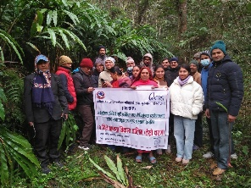  Livelihood: refresher training to cardamom farmers (Round 1-4), cardamom training to local government staffs & stakeholders, 5 numbers of wood combustor improved cardamom dryer installation support, learning & exposer visit to farmers, 43 improved breeding buck support and buck management training, goat value chain study, goat raring training, goat shelter support, market linkage, life skill training provided to COVID affected HHs, Cash for work, business startup support, etc.  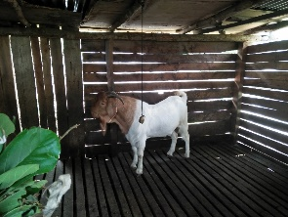  DRR: awareness rising on DRR to local level, provide support to local government to prepare the DRR plan & implementation, support to reactivate the LDRMC & WDRMC, Support to local government about the registration of landslide affected & disaster affected HHs on NDRRMA system, coordination with stakeholders, psychosocial counselling, detail geological study of Shyamchet landslide etc.
4.49.
Name of the Program | Covid-19 Response project (Dhaka Handicraft Training) | Thematic Area of Program | Livelihood
Project Duration | From: January 2021  To: September 2022 | Budget | 500000
Project Area | Ajirkot RM | Project Partner | Melania
Key Activities | 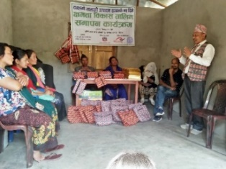  Community mobilization, participants selection, 45 days skilled base training on Dhaka knitting, make materials of dhaka, market linkage, develop the business plan etc.
4.50.
Name of the Program | Gorkha Landslide Response (GLR) Program | Thematic Area of Program | Shelter, DRR
Project Duration | From: August 2022  To: October 2022 | Budget | 5,779,250.67
Project Area | Aarughat RM | Project Partner | CRS Nepal/Start Fund
Key Activities | 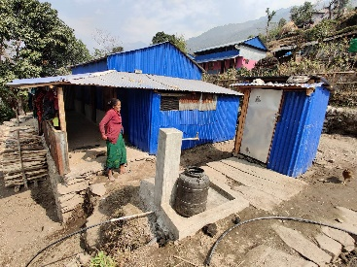  Community mobilization, Rapid assessment of the landslide, coordination, safe land selection support, coordination with Aarughat RM, DDRMC, Donor etc, landslide affected HHs finalization, transitional shelter (two room, one kitchen, one toilet and one drinking water tap per household) support to 28 Shyamchet Landslide affected HHs, detail geographical study of shyamchet landslide, solar light distribution, shelter tools kit support, socio-technical assistance, orientation to masons, conformation of cost sharing with RM, beneficiaries and project, psychosocial counselling, IEC materials distribution, monitoring visit by RM, CRS, Start fund, District level and SWC, social audit and handover ceremony etc.
4.51.
Name of the Program | Community Resilient Project (CRP), Gorkha under Project on Participatory Rural Recovery (PPRR) | Thematic Area of Program | Livelihood & Eco-Tourism
Project Duration | From: November 2022  To: July 2023 | Budget | 13604135.37
Project Area | Barpak Sulikot RM and Palungtar Municipality of Gorkha | Project Partner | JAICA Nepal
Key Activities | 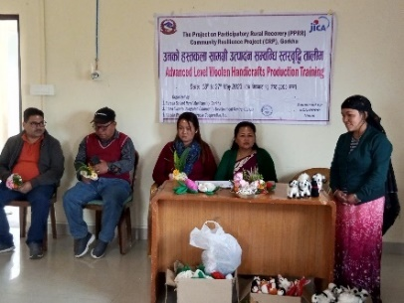  Community mobilization, life skilled training, bamboo and wool handicraft production support, support to barpak webinar/ koseli ghar for local agro & cultural production promotion, seasonal and off seasons vegetable cultivation training to farmer groups with input support, market survey, commercial goat farming training, market linkage, goat shelter construction support, improved breeding buck support, exposer visit to farmers and handicraft producers, IEC materials distribution, monitoring visit by RM, JICA Nepal, District level, social audit and handover etc.
5. Assets:
S.N. | ITEM DESCRIPTION | QTY | S.N. | ITEM DESCRIPTION | QTY
1 | Laptop Computer | 14 | 18 | Office T-Table | 6
2 | Office Chair | 24 | 19 | Desktop Computer | 1
3 | Plastic Chair | 30 | 20 | External Hard Disk | 2
4 | Meeting Chair | 12 | 21 | Projector | 3
5 | Cupboard | 22 | 22 | Avini Level | 2
6 | Mobile Phone | 17 | 23 | Scanner | 2
7 | Wooden Table | 3 | 24 | Computer Table | 4
8 | Steel Open Rack | 7 | 25 | Heater | 3
9 | Office Table | 15 | 26 | GPS | 2
10 | Camera | 5 | 27 | Invertor | 1
11 | Celling Fan | 4 | 28 | Projector Screen | 1
12 | Printer | 11 | 29 | Sofa set | 1
13 | Meeting Table | 1 | 30 | Stand-Fan | 1
14 | Wooden File Rack | 9 | 31 | Steel Glass Rack | 3
15 | Power Bank | 10 | 32 | Water Dispenser | 2
16 | Motorbike | 3
17 | Steel Table | 8

‘Thank you’

